**Extract Data**

Open SQL Server Import and Export Data

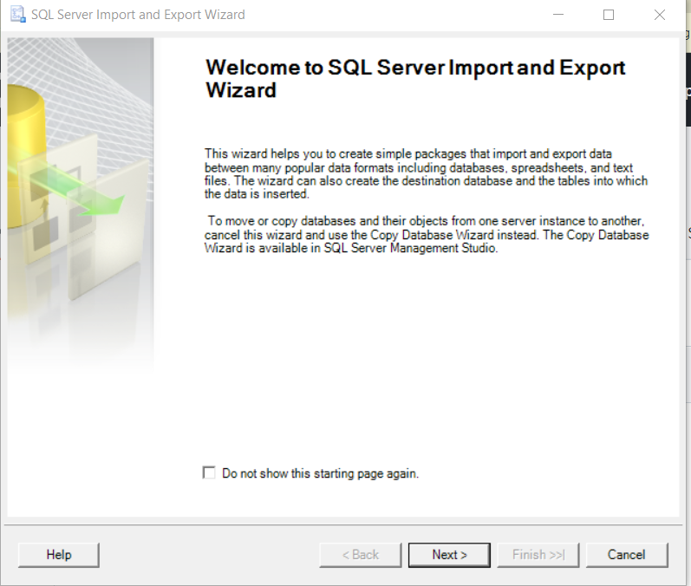

Choose Microsoft Excel as Destination

Browse for Excel file where you downloaded it to your computer

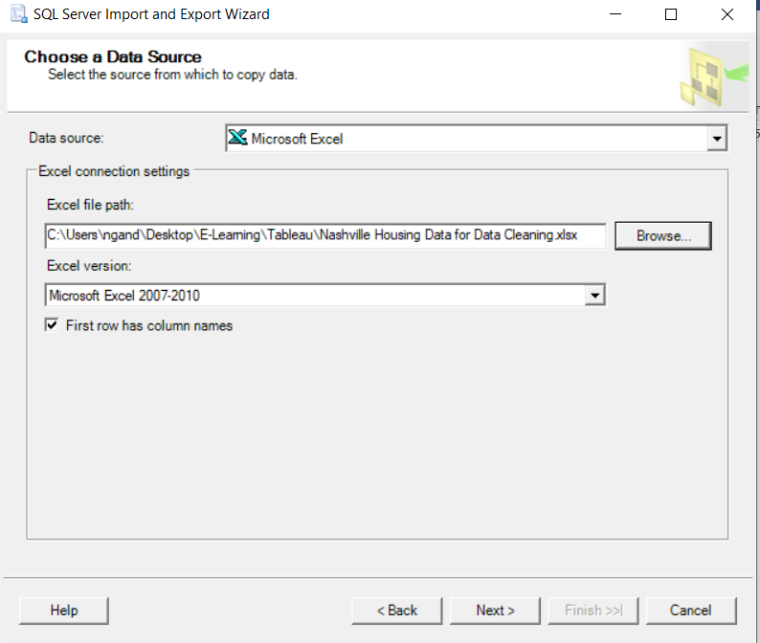

Chose SQL Server Native Client 11.0 as Data source

Chose Server Name

Choose Database

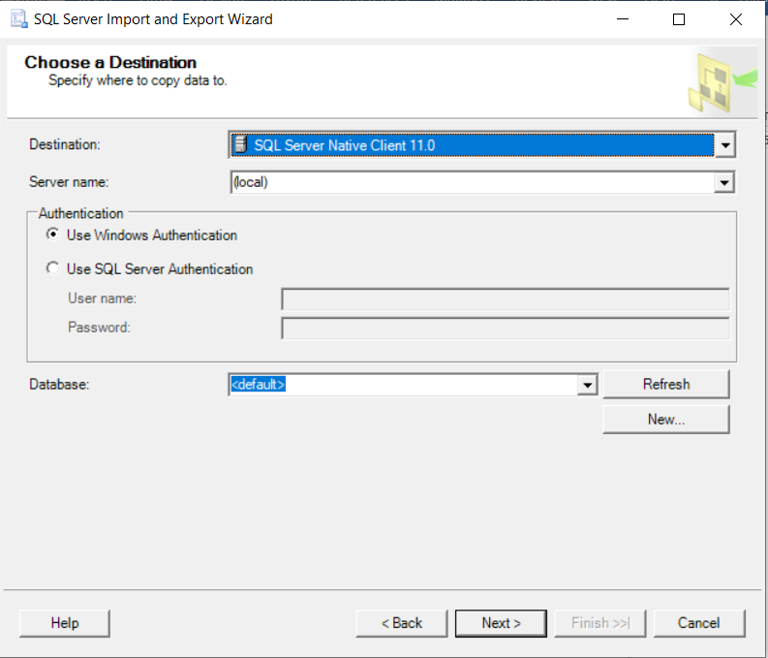

Chose Source, it will display Destination with same Source name

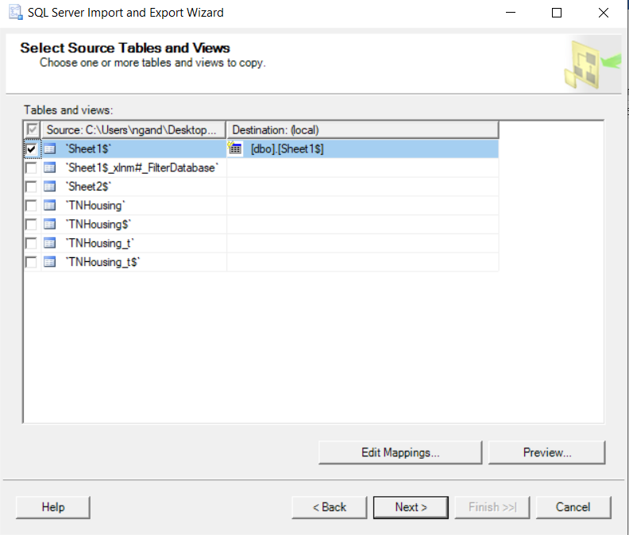

Copy data

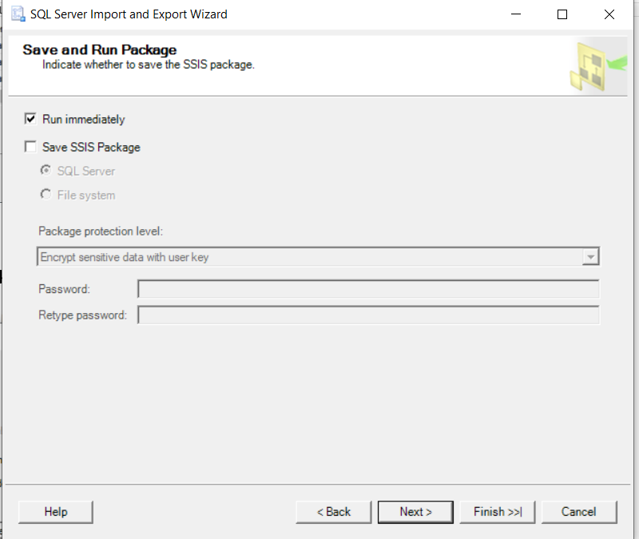

Finish and successfully copy data

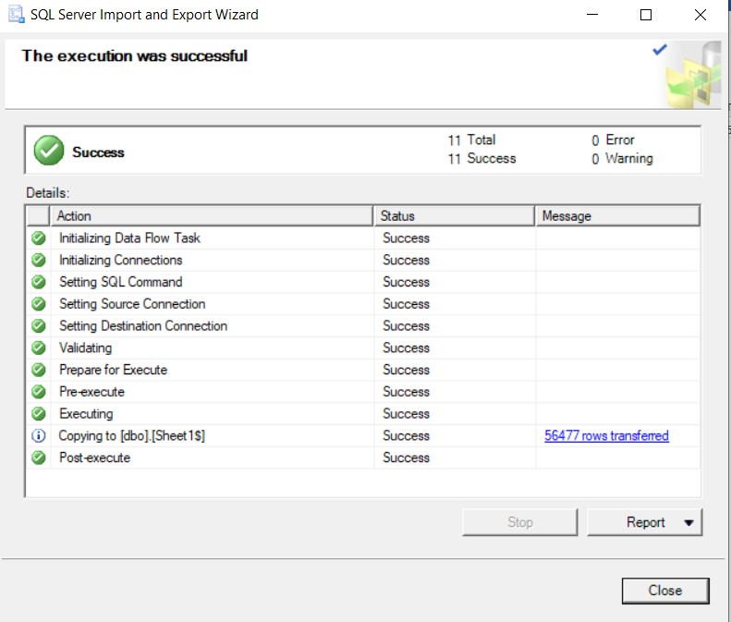

Rename table, columns data types…

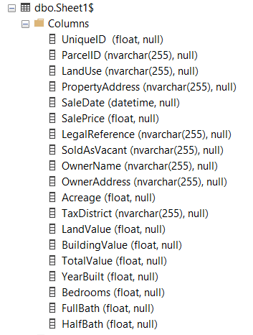

**Now data is ready in SQL Server for Cleaning data steps**